Senceball

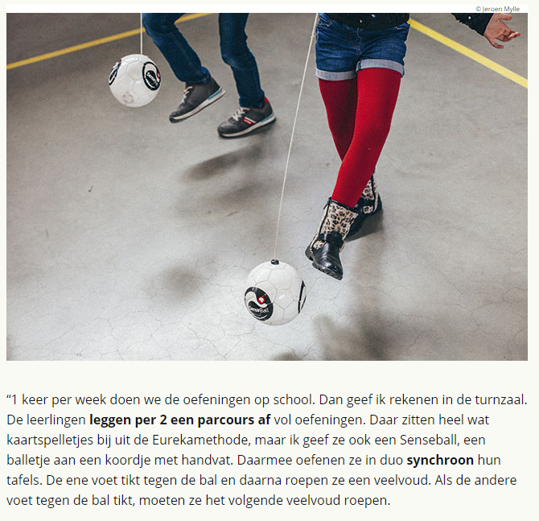

https://www.youtube.com/watch?v=XQIlTh-mE5Q

